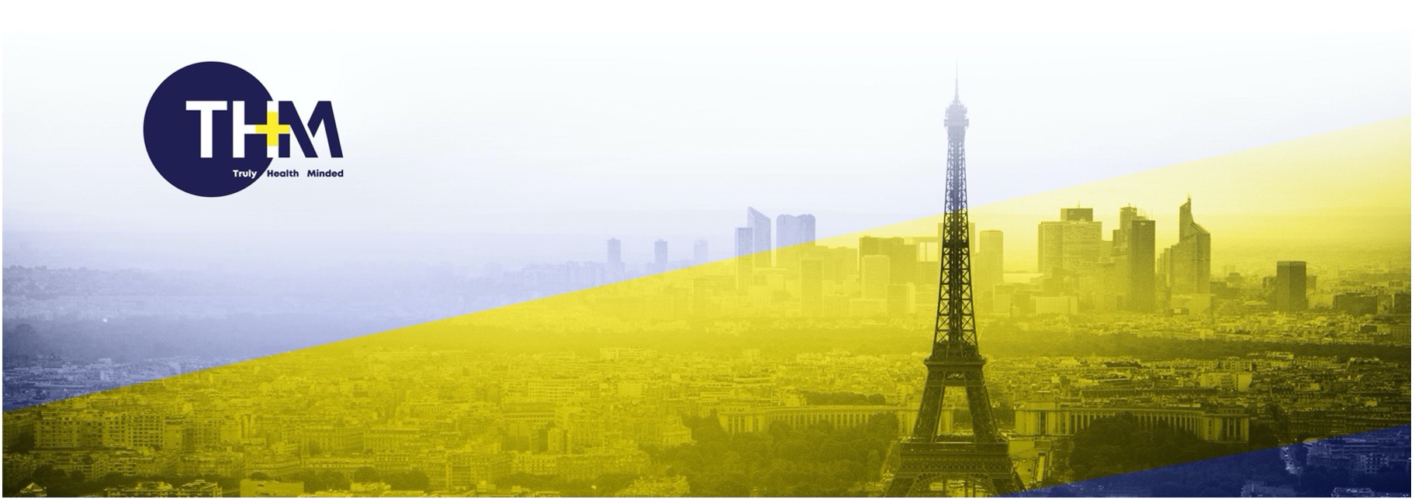

**Press release |** Paris, July 9, 2024

THM Capital Advisory acts as Sole Financial Advisor

to the shareholders of Alicante on its sale to Ospi

|  |  |  |  |  |
| --- | --- | --- | --- | --- |
|  |  |  |  | Lauxera Capital Partners |

Ospi (formerly PSIH Group) acquired Alicante (Lille, France), a software company in the field of medical coding and health data management through Artificial Intelligence, after the acquisition of Collective Thinking in 2023.

Ospi’s strategy consists in improving the efficiency of healthcare centers and accelerating clinical research for the benefit of patients. The planned merger between Collective Thinking and Alicante will enable Ospi to enrich its offer and leverage its portfolio of hospitals.

Alicante has been a pioneering company for 25 years, developing expertise in Artificial Intelligence focused on semantic analysis search engines dedicated to hospital data. Since 2018, Alicante has been selling a software suite that allows public and private hospitals to optimize, automate, and control the quality of their PMSI coding (coding of medical procedures performed), which is the main source of revenue for these healthcare centers, paid by the CNAM (French national health insurance).

The shareholders (private shareholders and regional investment funds) of Alicante had mandated THM Capital Advisory to find a strategic partner with financial means and a market-leading position.

David Delerue, CEO and co-founder of Alicante, becomes Director of the Medical Coding Business Unit: "Our clients will benefit from a unified, innovative offer and an enhanced support thanks to a common technical DNA among the companies of the Ospi group."

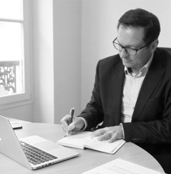

THM Capital Advisory advises Healthcare companies at each crucial

stage of their development.

**THM Capital Advisory – Truly Health Minded**

**PARIS** – 2 rue de Tocqueville, 75 017 Paris – **Tel** : 09 72 22 18 11

**LONDON** – 11 Epirus Road, Fulham, London SW6 7UR – **Tel** : + 44 77 151 731 98

www.thm-ca.com

**SELL-SIDE ADVISORS: Financial:** THM Capital Advisory(Thomas Mitard, Aurelien Prost); **Legal**: Bignon Lebray (François Vibert, Felicien Hyest)

**ACQUIRERS:** OSPI (Jean-Baptiste Angeloglou, Matthieu Andre, Elise Masse); Lauxera Capital Partners (Pierre Moustial, Edoardo Fracchia, Victoire Ribert)